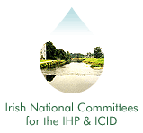
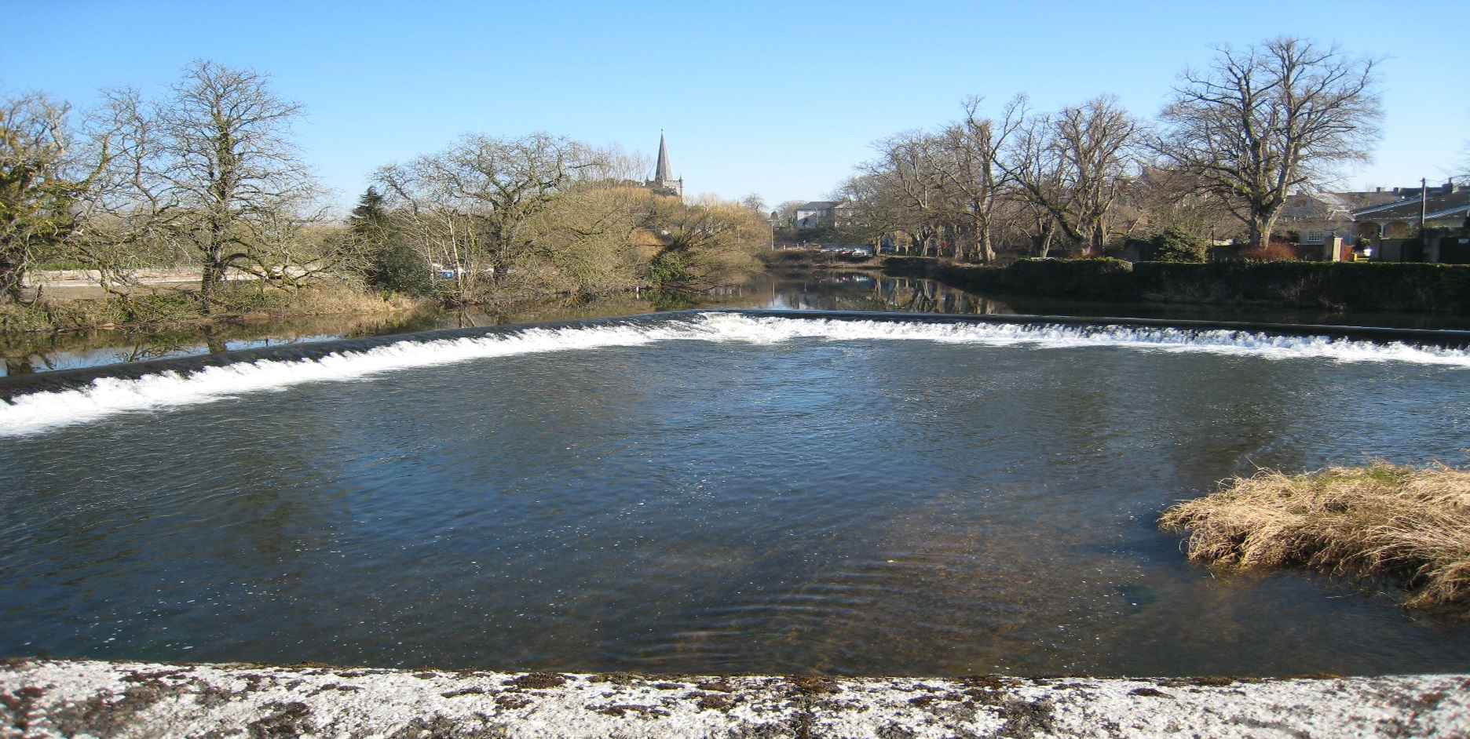
Irish National Hydrology
Conference 2018
Hydrology and Community Involvement

First Announcement

Tuesday, 20th November 2018

Mullingar Park Hotel

Mullingar, Co. Westmeath

Introduction
The National Committees of the IHP/ICID invite you to Mullingar for the 19th National Hydrology Conference to be held on Tuesday 20th November 2018 at the Mullingar Park Hotel. This event is Ireland's leading Conference devoted to Hydrology providing a unique forum for attendees to share policy developments, research results, and practical solutions to engineering hydrology issues.

Conference Theme ..
The theme of this year’s conference will focus on the interaction between hydrology and communities. Interactive community engagement and involvement is crucial for the successful implementation of water policies and projects. Allowing all stakeholders to bring forth their concerns and opinions can lead to reduced delays and costs, improved design, and a higher level of acceptance amongst the community. Increasingly the idea of community based (citizen science) monitoring and observation networks is gaining acceptance for enhancing the design of water related projects. It is therefore important to highlight the mutual benefits that can be gained from the participation of communities in the hydrological design process.

Organisers
International Hydrological Programme (IHP) .
The UNESCO international scientific co-operative programme in hydrology and water resources, the IHP, was established to act as a catalyst to promote co-operation and research in the management of water resources, an issue which had been identified as a significant limiting factor for harmonious development in many regions and countries of the world.

International Commission on Irrigation and Drainage (ICID)
The mission of the ICID is to stimulate and promote the development of the management of water and land resources for irrigation, drainage, flood control and river training applications, including research and development and capacity building.
Conference Booking & Costs .
Demand for places at previous Conferences has been high. Places are allocated on a first-come basis, and pre-booking is essential (using the registration form on this page). The cost of attendance at the Conference is €125 per person (with a limited Student rate of €40), which includes a Book of Proceedings on USB key, refreshments and lunch. Invoices will be issued following receipt of registration forms requesting the reservation of a place. Receipts will only be issued upon demand.

Please note that we there will be no refund or waiver of invoice for cancellations received later than Friday, 16th November.

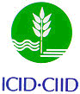

Irish National Hydrology
Conference 2018

Conference Opening
09:00 | Conference Registration (Tea, Coffee & Pastries)
10:00 | Welcome – Kevin Moran, T.D., Minister of State for the Office of Public Works and Flood Relief.

Session 1: Community Engagement
10:20 | Keynote Address: Community and the Environment: Prof. Tom Collins (Chair, National Water Forum)
10:40 | Rehabilitation of the Camac River under the Water Framework Directive: New Opportunities to Engage Local Communities and to Manage Flood Risk
 | Mary-Liz Walshe (Dublin City Council)
11:00 | Conference Poster Presentations
 | Brief Introductions to posters on display in the exhibition area
11:30 | Discussion - Tea/Coffee

Session 2: Stakeholder Involvement
12:20 | CFRAM - 'Assessing Ireland's flood risk and setting a strategy for the future'
 | John Martin (Office of Public Works)
12:40 | Hydrology and communities: a hydrogeological study of Irish Holy wells
 | Bruce Misstear (Trinity College Dublin)
13:00 | Climate Change, Groundwater and Community: Findings from a national survey of Irish well owners about flood-triggered contamination of private supplies
 | Luisa Andrade (University College Dublin)
13:20 | Discussion - Lunch

Session 3: Catchment Management
14:30 | Characterising environmental flows in Ireland and what this means for water resource management in Ireland
 | Conor Quinlan (Environment Protection Agency)
14:50 | Development of an automated tool to undertake a National Flood Risk assessment
 | Patrick Rath (RPS Consulting Engineers)
15:10 | Analysis of Runoff from Irish Peatland Catchments to Support the Development of Drainage Management Plans for Raised Bog SACs
 | Brendan Quigley (RPS Consulting Engineers)
15:30 | Discussion
15:40 | Comfort Break

Session 4: Groundwater
15:55 | Developing historic and predictive groundwater flood maps for Ireland
 | Naughton, Owen (Geological Survey Ireland)
16:15 | Groundwater flood modelling in the karst lowlands of South Galway
 | Patrick Morrissey (Trinity College Dublin)
16:35 | Discussion
16:45 | Close

09:00 – 15:30 Poster Exhibition
Posters will be on display in the exhibition area all day during the breaks in the conference programme.

Registration / Further Information .
To register to attend the conference or to request further information, please complete the registration form and return (with payment to confirm a booking) to:
Contact: IHP/ICID Secretariat,
Office of Public Works, Head Office,
Trim,
Co. Meath, Ireland.
Tel: 046 942 6737
E-mail: nhc@opw.ie
All payments to be made by Electronic Fund Transfer (EFT)
BIC - DABAIE2D
IBAN - IE91DABA95167890052841
Please send remittance to receipts@opw.ie and reference the National Hydrology Conference.

Registration Form
Name:
Job Title:
Organisation:
Address:
Purchase Order No. (if applicable):
Tel: Fax:
E-mail:

